MRP CHARGER Product user GUIDE
IMPORTANT – Please carefully read this information prior to use

Mounting:

This charger can be mounted in several different configurations:

1. Preferred mounting orientation • Horizontally flat mounted with fan (handle) facing upwards with no obstruction • Vertically mounted with AC/DC cords facing up or down • Side mounted with AC/DC cords facing left or right

2. Non-Preferred Mounting Orientation • Horizontally mounted with fan (handle) facing the ground Page NOTE: Always mount the charger to a noncombustible material surface(metal/ brick/concrete). When choosing an installation location, ensure there is space around the fan of at least 78mm to provide sufficient cooling - at minimum 3 inches.

WARNING – 1, To reduce the risk of fire, install this battery charger on a surface of non-combustible material such as brick, concrete, or metal. 2, To reduce the risk of electric shock it is recommended to disconnect charger from AC power after using. 3. Risk of electric shock do not touch uninsulated portion of AC or DC connectors or uninsulated battery terminal. 4. Ventilate the area when the battery is charging in an enclosed place. Never smoke, use an open flame, or create sparks near the battery. 5. The surface temperature is high during charging, please do not touch. 6. Only a qualified service technician should program or maintain and install the chargers.

DANGER 1. A grounded outlet is required to reduce risk of electric shock 2. Charge only batteries of the same type, voltage, cell number, and amp hour capacities as shown on the label. Other types of batteries may burst causing personal injury and damage. 3. Do not operate this charger if AC supply cord/plug or DC output cable/plug/connector is damaged, or if the charger has received a sharp blow or is damaged in any way 4, Connect the charger to a suitable power supply which has all the appropriate circuit protection devices in place (fuses/circuit breakers etc)

NEVER – Disconnect the DC coupling/connector whilst the charger is operation, this may cause a spark which could ignite the gases being released from the battery resulting in explosion

Specification of Battery Charger
Model | WT7260PH

Model | WT7260PH
Output voltage | 72V
Output current | 60A±5%
Battery Specifications | WET (standard)-AGM/GEL-options to be pre specified
Max. output power | 4500W

No. | Item | Technical specification | Remark
1 | Humidity | 10-95% RH | /
2 | Altitude | ≤2000m | Work normally

No. | Item | Technical specification | Remark
1 | Rated input voltage | □100-120Vac □200-240Vac ☑346-412Vac | /
2 | Input voltage range | □90-132Vac □180-264Vac ☑260-457Vac | /
3 | AC input voltage frequency | 45-65Hz | /
4 | Power factor | PF＞0.9 | /
5 | Incoming current | Max9A | /
6 | Power efficiency | ≥90% | Vin=220Vac Rated load

No. | Item | Technicalspecification | LED | FAN | Remark
1 | Nominal voltage | 72V | / | / | /
2 | V-out | 60V ~ 95.4V | / | / | /
3 | Standby | No-output | Alternating red and green | Fan shutdown | /
4 | PREC  precharge | I-out= 30A | Red flash | Fan rotation | 60V≤V-out≤72V
5 | Bulk charge | I-out =60A | Red flash | Fan rotation | 72V≤V-out≤86.4V
6 | Transition Current | I-out =30-60A | Yellow flash | Fan rotation | V-out=86.4V
7 | Float | I-out=30A | Yellow flash,When the voltage rises to 95.4V or the total charging time reaches 17 hours, the charging indicator light will turn to a steady green light. | Fan rotation | 86.4V≤V-out≤95.4V

PROTECTION CHARACHTERISTICS
No. | Item | Technical specification | Remark
1 | Software over voltage protection | The charger output voltage does not exceed set the maximum charging voltage of the battery. | /
2 | Current limiting protection | The charger output current does not exceed a set battery charge current. | At CC mode
3 | OVP | When the output overvoltage occurs, the charger turns off the output and automatically recovers after the overvoltage is relieved | /
4 | Input voltage fault | When the power supply exceeds the input voltage range, the charger does not work. The power supply can be restored after it is normal. | /
5 | Output short circuit | When the charger output short circuit, cannot work normally, after the short circuit disappears, the charger automatically restores | /
6 | Over-temp protection | When the internal temperature of the charger exceeds 65 ° C, the charger output derates to 30%  After the temperature returns, restart the charger to return to normal

SAFETY & EMS
No. | Item |  | Standard (or test condition) | Remark
1 | Electric strength test | Input-output | 1500Vac/60s ≤5mA | No breakdown
2 | Isolation resistance | Input-ground | ≥100MΩ@500Vac | /
2 | Isolation resistance | Output-ground | ≥100MΩ@500Vdc | /

ENVIRONMENTAL TESTING REQUIREMENTS
No. | Item | Technical specification | Remark
1 | High environmental temperature ambient operating | +45℃ | Features OK
2 | Low environmental temperature ambient operating | -20℃ | Features OK
3 | High temperature storage | +70℃ | Work normally after recovery under normal temperature for 2 hours
4 | Low temperature storage | -40℃ | Work normally after recovery under normal temperature for 2 hours
5 | Random vibration | 20Hz to 500 Hz Acceleration 0.49 | /
6 | Repetitive shock | 10Hz to 60Hz Amplitude 0.38 | /
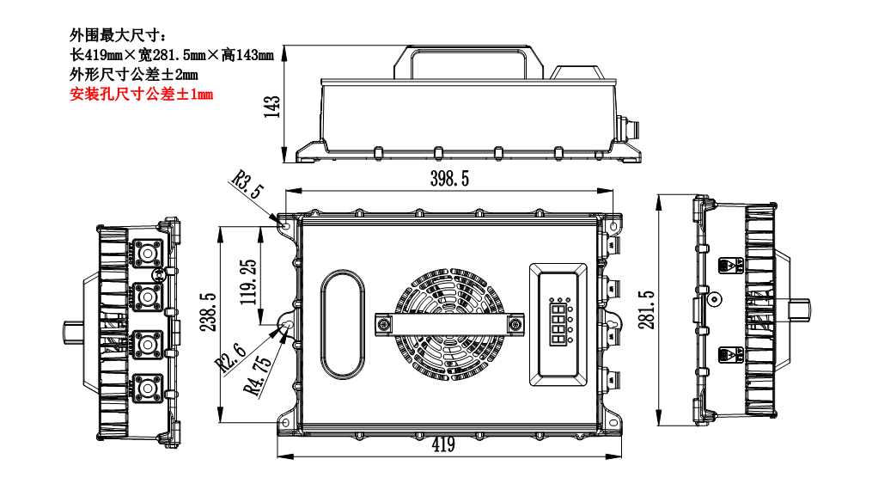

Maximum peripheral size：
Paperback: L 419mm×W 281.5mm×H 143mm
Dimensional tolerance±1mm
Mounting hole size tolerance±0.5mm

Package, transportation & storage:
There is product name, model, name of manufacturer, safety approval, serial number, User Manual and packing
list in the package box.

Transportation:
Suitable for transportation by road, the products should be Placed in cool dry place, and loaded and unloaded carefully.

Storage:
Products should be stored in package box when it is not used. And Warehouse extreme temperatures should be -40 ~ 70 ℃, the normal temperature -20 ~ 50 ℃, and relative humidity is 5~95%. In the warehouse, there should not be harmful gas, inflammable, explosive products, and corrosive chemical products, and strong mechanical vibration, shock and strong magnetic field affection. The package box should be above ground at least 20cm height, and 50cm away from wall, thermal source, and vent. Under this requirement, product has 2 years of storage period, and should be rechecked when over 2 years.

Reliability requirements
MTBF ≥50k
MTBF (standard, environmental temperature, load requirement) ≥50K hours;
testing condition: 25℃,full load, testing proved value.

